H.T No
Regulations:
A18

Sreenidhi Institute of Science and Technology
(An Autonomous Institution)
Code No: 7B310 Date: 30-Sept-2021(FN)

B.Tech II-Year I- Semester External Examination, Sept/Oct-2021 (Supplementary)
MACHINE DRAWING AND COMPUTER AIDED DRAWING PRACTICE (ME)

Time: 3 Hours Max.Marks:70

Note: a) No additional answer sheets will be provided.
b) All sub-parts of a question must be answered at one place only, otherwise it will not be valued.
c) Missing data can be assumed suitably.

Bloom's Cognitive Levels of Learning (BCLL)

Remember | L1 | Apply | L3 | Evaluate | L5
Understand | L2 | Analyze | L4 | Create | L6

ANSWER ALLTWO QUESTIONS.

1. |  | ANSWER ANYTWO FROM QUESTION 1. | BCLL | CO(s) | Marks
 | a) | Draw the front, top and left hand side view of a 30mm diameter hexagonal headed bolt with a nut and a washer and show all the dimensions with suitable proportions | L3 | CO2 | [15M]
 | b) | Draw the sectional front, top view of a cotter joint with a sleeve to connect two pipes diameter 30mm each. Show the proportions and suitable dimensions | L3 | CO2 | [15M]
 | c) | Draw the full-sectional front view and top view of a single riveted single strap butt joint for plates of 15mm thickness. Illustrate pitch, row pitch, diagonal pitch and margin. | L4 | CO3 | [15M]

2. | Assemble all the parts shown in the figure  (i) Half sectional view from the front (ii) Top view | [40M]
 | 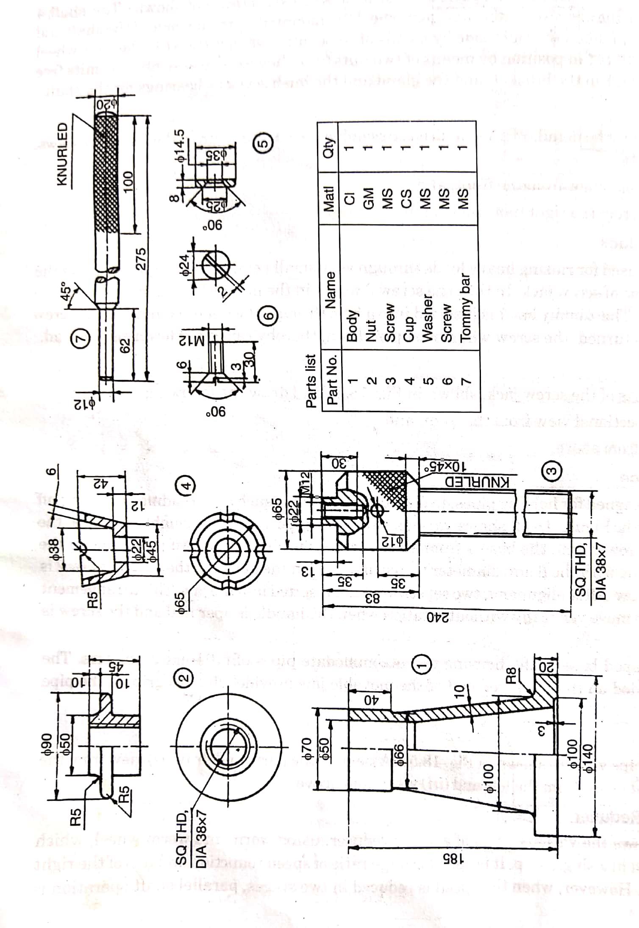

-- 00 -- 00 –

